**PRISON ESCAPE**



**Session 2023 - 2027**

**Submitted by:**

Abdul Rehman 2023-CS-73

**Supervised by:**

Dr. Muhammad Awais Hassan

**Course:**

CSC-102 Programming Fundamentals

Department of Computer Science

**University of Engineering and Technology**

**Lahore Pakistan**

**Table of Contents**

**1.** **Short Description and Story Writing of your Game:** 3

**2.** **Game Characters Description:** 3

**2.1** **Player:** 3

**2.2** **Enemies:** 3

**3.** **Game Objects Description:** 3

**3.1 Score pills:** 4

**3.2** **Health Increment:** 4

**3.3 Health Increment:** 4

**3** **Goal of the Game:** 4

**Wireframes of the Game:** 4

**4** **Data Structures:** 5

**5** **Function prototypes** 6

# 

# **Short Description and Story Writing of your Game:**

It is a story of a person who was kept in jail for years once he tries to escape the prison. The jail at which he is kept has high security so if he has to escape it he must kill all the officers and guards.

# **Game Characters:**

# **Player:**

There is one human player in the Game.

Prisoner who is a convicted criminal. He has to escape the jail in order to win the game. Its health is 100% and its health decreases by 5 if bullet hits it!

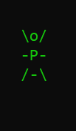

* 1. **Enemies:**

There are 4 enemies in the game.

**Guard**  
A guard has the health of 100% and decreases by 10 if player hits it. It can fire in 3 directions. It has highest fire rate but lowest health.

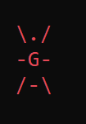

**Officer**

An officer has the health of 150% and decreases by 10 if player hits it. It can fire in all directions. It has medium fire rate and medium health.

**Special guard**

A special guard has a health of 200% and decreases by 10 if player hits it. It has highest health and lowest fire rate.



**Boss**

Boss arrives if player kills 2 enemies. It has a health of 500%. If player kills it, he wins the game. It can fire in all directions.

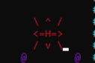

Enemies fire bullets if the find player in their range

# **Game Objects Description:**

Following are the Objects in the Game

# **3.1 Score pills:**

There are @ score pills in the maze which has to be collected by player. It will increase its score by 1. Score players are generated randomly in the game.

# **3.2 Health Increment:**

When the player kills special guard a shield S appears on screen which if kept by player its health increments by 100%.

# **3.3 Guns:**

There are two types of guns:

‘G’ the gun with a small fire rate and fires 1 bullet then halts and then fires bullet.

‘M’ the machine gun that fires continuously.

**Rules & Interactions:**

1. Save player from enemy bullets. If bullets hit player health decreases.
2. Kill the boss and all other enemies to win the game
3. If player presses left shift game pauses till the player again presses right shift key.
4. Player cannot fire till he collects the gun ‘G’ or ‘M’

# **Goal of the Game:**

The goal of the game is for the player controlling the character prisoner to kill all the enemies to escape the jail.

# **Wireframes of the Game:**

Following are the wireframes of my game:

* **Front Menu:**

It is the first menu shown to the user. In first menu 3 options are given to user.

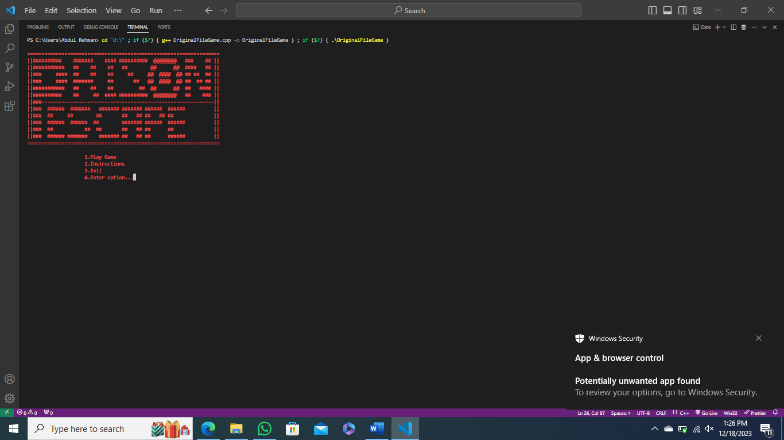

**Figure.1 Menu**

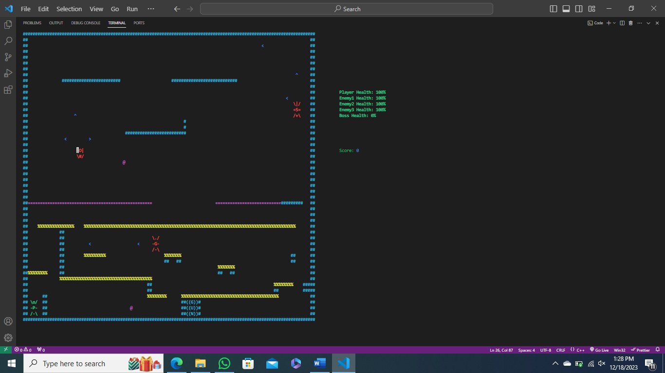

**Figure.2: Game screenshot**

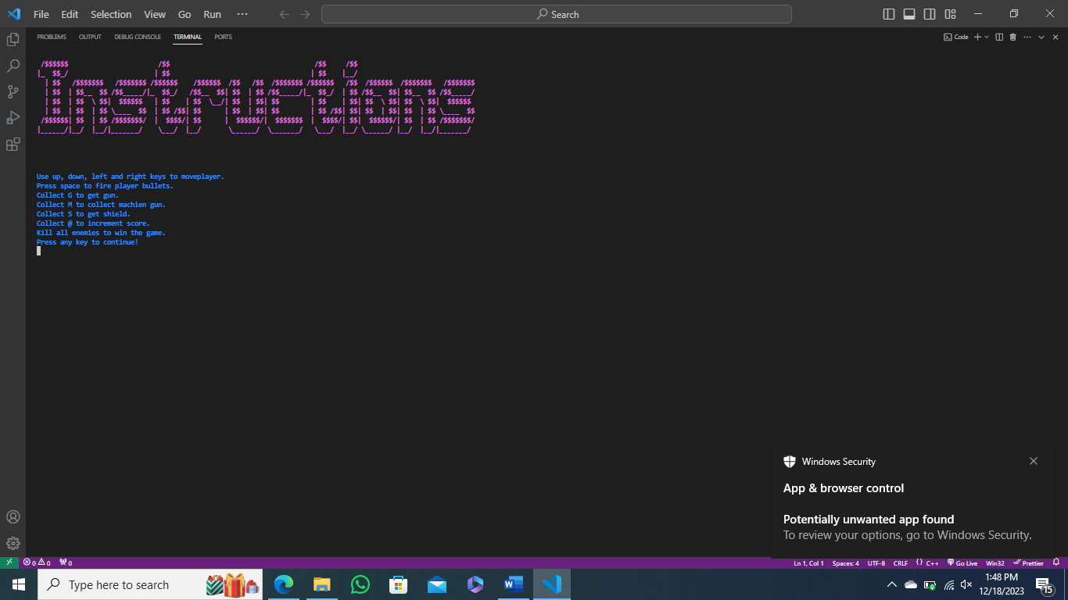

**Figure.3: Instruction Panel**

# **Data Structures:**

char bullet[5] = {'|', '<', '>', '^', 'v'}; // bullets fired by players and enemies

int eX1 = 40, eY1 = 35; // coordinates of enemy 1

int eX2 = 10, eY2 = 7; // coordinates of enemy 2

int eX3 = 111, eY3 = 1; // coordinates of enemy 3

int pX = 3, pY = 46; // coordinates of player

int score = 0; // score of player

int playerHealth = 100;

int eBX = 50, eBY = 12;

char playerGun = '!';

char pKey = 'D';

int health[4] = {100, 150, 200, 0};

string menu[4] = {"Play Game", "Instructions", "Exit", "Enter option..."};

string directionEnemy1 = "right", directionEnemy2 = "movediagdown", directionEnemy3 = "movedown", bossDirection = "right";

bool en1 = true;

bool en2 = true;

bool en3 = true;

int enemy1FireCount = 0;

int enemy2FireCount = 0;

int enemy3FireCount = 0;

bool enemy1FireFlag = false;

bool enemy2FireFlag = false;

bool enemy3FireFlag = false;

bool playerGunPlacement = false;

bool playerShootType = false;

bool winStatusLevel1 = false;

bool bossArrival = false;

bool pillGeneration = false;

# **Function prototypes**

void header();

void printBoard();

void printEnemy1();

void eraseEnemy1();

void moveEnemy1(string);

string changeDirectionEnemy1(string);

void printEnemy2();

void eraseEnemy2();

void moveEnemy2(string);

string changeDirectionEnemy2(string);

void printEnemy3();

void eraseEnemy3();

void moveEnemy3(string);

string changeDirectionEnemy3(string);

void printBoss();

void eraseBoss();

void moveBoss(string);

string changeBossDirection(string);

void printPlayer();

void erasePlayer();

void movePlayer();

void movePlayerLeft();

void movePlayerRight();

void movePlayerUp();

void movePlayerDown();

void scorePill();

void generatePill();

void generateGun(int);

string printMenu();

void gameWin();

void InstructionsMenu();

void playerBulletsFiring();

void moveBullet(string directionEnemey1, string directionEnemy2, string directionEnemy3);

void enemy1BulletFiring(string directionEnemey1, string directionEnemy2, string directionEnemy3);

void bulletCollisionEnmeies(int, int, string directionEnemey1, string directionEnemy2, string directionEnemy3);

void bulletCollisionPlayer(int, int);

void gameWin();

void gamelose();